
BIN 381 Milestone 4
Group P1

Alexander Solomon (601638)
Timothy Wubbeling ()
Rudi Jan du Plessis ()

Table of Contents
1. Business problem and approach 2
1.1 The Problem 2
1.2 How we followed CRISP-DM 2
2. Data strategy, integration and preparation 3
2.1 Data selected 3
2.2 Cleaning decisions that changed the result 3
2.3 Integration 4
2.4 Target, predictors and data split 5
3. Modelling 5
3.1 Framing 5
3.2 Techniques and preprocessing 5
3.3 Validation and tuning 6
3.4 The change to a binary model 6
3.5 Reproducibility 6

Business problem and approach

The Problem
Households that cannot reliably get enough food are hard to find when support budgets are limited. We worked as analysts for a policy institute of the Department of Social Development type, which must decide which households to prioritise for follow-up and referral. Our evidence is the Stats SA General Household Survey (GHS) 2024, which records 20,940 households and asks eight questions about running out of food, skipping meals and going hungry (Statistics South Africa, 2026).
The project had three business objectives, set in Milestone 1:
- BO1. Identify and rank the five to eight household indicators most associated with food insecurity, with p < 0.05 and an effect size.
- BO2. Build an interpretable classification model, without leakage, that is evaluated on held-out data and can be used to prioritise households.
- BO3. Give decision-makers self-service exploration by province and household characteristic, delivered as a Power BI dashboard (Section 5).
We linked these to six hypotheses about what puts a household at risk: falling income (H1), settlement type (H2), large households and low income per person (H3), no electricity (H4), social grant receipt (H5) and poor sanitation (H6). Section 4 reports which were supported.

1.2 How we followed CRISP-DM
We followed the CRISP-DM phases in order (Chapman et al., 2000) and went back when the evidence required it. Table 1 shows where each phase occurred and the most important decision in each.
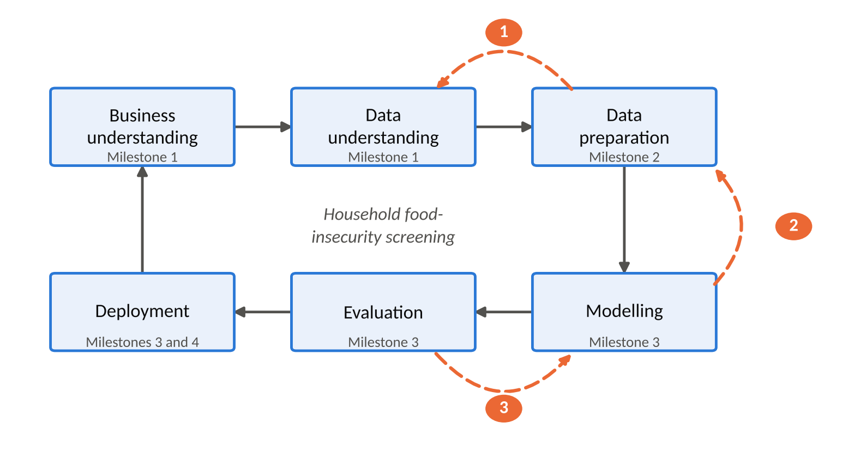

Phase | Milestone | Main Decision
Business and data understanding | 1 | Framed the problem as targeting limited support; explored all 11 GHS files; set B01 to B03 and H1 to H6.
Data preparation | 2 | Kept seven household-level files, repaired keys and duplicates, built the food-insecurity target and the predictors, and fixed one stratified train/test split.
Modeling | 3 | Tuned three classifiers with stratified cross-validation, then added a binary model when the three-tier target proved too hard.
Evaluation | 3 | Judged models on imbalance-aware metrics and chose a referral threshold of 0.24 on the training data only.
Deployment | 3 and 4 | Released an R/Shiny screening tool with validation, monitoring and retraining triggers, and a Power BI dashboard for exploration.

Three times the later work changed an earlier decision. Milestone 1 reported 256 to 272 duplicate household IDs per file, but in Milestone 2 we found this came from reading 18-digit IDs as numbers (Section 2.2). The urban/rural coding of settlement type assumed in Milestone 2 was corrected to the three levels in the data dictionary before modelling. For deployment, we replaced the three-tier target set in Milestone 2 with the binary fallback we documented in advance (Section 3.4).

Data strategy, integration and preparation

Data selected
The GHS 2024 comes as eleven files, D01 to D11. We analysed households, so one row is one household, and the key is HouseholdID. Seven household-level files were kept: dwelling conditions (D04), basic services (D05), energy (D06), household well-being (D07, which holds the food-insecurity items and acts as the anchor), connectivity (D08), household resources (D09) and mobility (D10). D08 was not in the Milestone 1 core set. We added it because it is household-level, joins without mismatch, and digital exclusion is a recognised dimension of deprivation.
Three files were left out on purpose. D01 to D03 are person-level (about 70,450 rows against 20,940 households), so using them would force an extra aggregation choice for every variable, and none of H1 to H6 needs a person-level variable. D11 (labour market) comes from a different survey with a different sampling universe and has no household IDs in common with the GHS.

Cleaning decisions that changed the result
We cleaned each file before joining and logged every treatment (data/clean/qa_log_personC.csv). Table 2 lists the decisions that had a real effect on the final dataset.
Problem | Decision | Effect
18-digit HouseholdID read as a number loses its last digits (R holds only 15 to 16 digits exactly) | Read every ID as text. | The "256 to 272 duplicates per file" in Milestone 1 disappeared. It was an artefact of rounding, not of the survey.
Exact duplicate rows in D04, D07 and D09 | Kept the first copy after checking every duplicate was a full row copy. | 20,956, 20,955 and 20,955 rows became 20,940 in each file. No information was lost.
Province typed as padded or mixed-case text (up to 31 variants in one file) | Rebuilt the label from the clean numeric province code. | Nine provinces in every file.
Refused, "unspecified" and "not recorded" codes (9, 99, 9999999 and text tokens) | Recoded to missing instead of treating them as real answers. | For example, 451 households have no usable income. They are imputed later inside the model recipe, using training data only.
Household size of 0 | Recoded to missing. Sizes 8 and 9 were kept as valid. | Removes an impossible value without discarding real large households.
Two D09 columns that look like counts but are not (salary earners, total grant recipients) | Excluded from the dataset. | Avoids feeding amounts and sentinels into a count predictor.

Integration
We joined D07 with the other six files one at a time, using guarded one-to-one joins that stop if a household would be dropped or duplicated. This mattered. Fifteen households in D05 carried placeholder keys ("UNMATCHED_…") instead of real IDs, so a plain inner join would have lost them without any warning. Because all files list households in the same order, we matched each placeholder to the ID at the same row position in D07, and then confirmed it with the household's province, settlement type and survey weight. Both checks agreed for all 15, so the keys were restored and the join went ahead.
The result is 20,940 households with no loss or duplication at any step. We tested it three ways: every source value survives the join unchanged (compared column by column with no tolerance), the descriptors that were dropped from the other files agree with the integrated values for all matched households, and the provincial household counts equal those in D07. These checks stop the notebook if they fail. The dictionary (data/integrated/BIN381_M2_Data_Dictionary.csv) records the source file and treatment of every column.
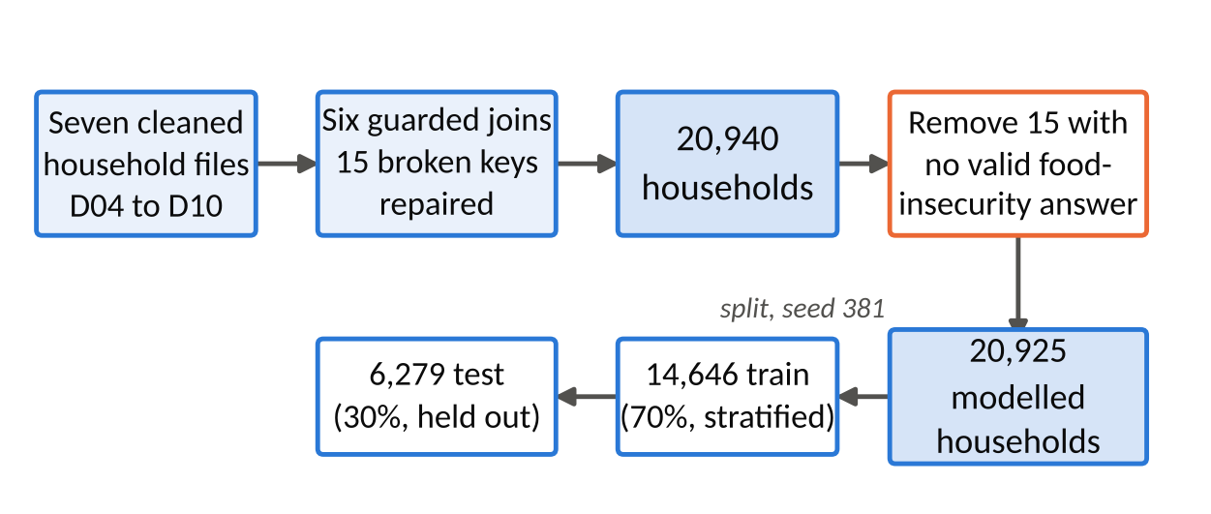

Target, predictors and data split
Target. The Food Insecurity (FI) Score counts the "yes" answers to the eight food-access items (0 to 8). An answer of "don't know/refused" is missing, not "no", because it is no evidence of food security. Fifteen households have no valid answer, so they cannot be scored and were set aside, leaving 20,925 modelled households. We grouped the score into three tiers: food secure (FI = 0, 69.45% of training households), food insecure (FI 1 to 3, 10.55%) and severely food insecure (FI of 4 or more, 20.00%). Any food insecurity (FI of 1 or more, 30.55%) was kept as a binary fallback.

Predictors. Each of the eight predictors comes from a hypothesis: income compared with a year ago (H1), settlement type (H2), household size and income per person (H3, with log income also used for H1), electricity access (H4), number of grant recipients (H5) and main toilet type (H6). Income is log-transformed because it is strongly right-skewed.
Leakage. The FI Score is built from the eight items, so they cannot also be predictors. We excluded 16 columns: the eight items, two older hunger questions, four "number of days" follow-ups, the FI Score and its count of answered items. The notebook asserts that none is in the predictor set or in the modelling data.
Split. A stratified 70/30 split on the tier (seed 381) gave 14,646 training and 6,279 test households, with the same tier mix in both. The test set was not used for any modelling decision.

Modelling

Framing
This is a supervised classification problem: given a household's income, size, settlement type and access to services and grants, how likely is it to be food insecure? We started with the three-tier target because BO2 asks for vulnerability tiers, and we wrote down in advance that we would fall back to the binary target if the thin middle tier (10.55%) could not be separated.

Techniques and preprocessing
We built three candidates, one more than the minimum, to cover the trade-off between interpretability and performance. Regularised multinomial logistic regression (glmnet; Friedman, Hastie & Tibshirani, 2010) is the interpretable baseline whose coefficients map onto H1 to H6. It assumes a linear relationship on the log-odds scale and low multicollinearity. We handled the first by log-transforming income and checked the second: income compared with a year ago, regressed on the two income features, gives R² = 0.064 and a variance inflation factor of 1.07, far below the usual concern level of 5. A decision tree (rpart; Therneau & Atkinson, 2026) gives readable rules, but is unstable, so we used it for interpretation and not as the performance candidate. A random forest (ranger; Breiman, 2001; Wright & Ziegler, 2017) of 500 trees is the performance benchmark, at the cost of being harder to interpret.
Each family has its own preprocessing recipe. Missing numbers are filled with the training median and missing categories with the training mode, rare toilet codes (under 2% of households) are pooled, and unseen categories are guarded against. The logistic model also gets dummy encoding and scaling, because its penalty is scale sensitive. All this sits inside tidymodels workflows, so it is re-learned inside every cross-validation fold and never sees the test set (Kuhn & Silge, 2022).

3.3 Validation and tuning
We tuned each model with 5-fold cross-validation on the training set, stratified on the tier so that every fold keeps the 69/11/20 mix. Candidates came from space-filling grids of 8 to 12 settings, and the selection metric was cross-validated ROC-AUC (the Hand and Till, 2001, version for three classes), which the majority class cannot inflate. Accuracy is misleading here because predicting "food secure" for everyone scores 69%.
We also tested class weights as an alternative way to handle imbalance. They raised recall for the severe tier from 25.8% to 58.7% but cut recall for food-secure households from 95.5% to 59.7% and worsened calibration (Brier score 0.289 against 0.205). The app reports a probability, so we kept the unweighted models and handled imbalance at the decision threshold instead (Section 4).
Model | Selected settings | CV ROC-AUC, three tiers | CV ROC-AUC, screening
Multinomial logistic (glmnet) | penalty 8.1 × 10⁻¹⁰, mixture 0.18 | 0.669 ± 0.007 | 0.734
Decision tree (rpart) | cost complexity 1 × 10⁻¹⁰, depth 11, min_n 19 | 0.658 ± 0.010 | 0.721
Random forest (ranger) | mtry 2, min_n 31, 500 trees | 0.673 ± 0.005 | 0.739
Binary logistic (glmnet) | penalty 1.9 × 10⁻⁶, mixture 1 (lasso) | not applicable | 0.733 ± 0.010
Screening AUC is the ability to separate food-secure from food-insecure households, from the sum of the two insecure-tier probabilities.

3.4 The change to a binary model
All three three-tier models rank households better than chance (cross-validated AUC 0.66 to 0.67), but on the test set none of them recall more than 3.2% of middle-tier households (the forest 0.3%; Section 4), and the differences between them are small. With these eight predictors, the middle tier cannot be separated from its neighbours, which is the condition we set in advance for the fallback. The Shiny app also returns one probability per household, which suits a two-class model. We therefore fitted a fourth model, a lasso logistic regression on any food insecurity, with the same predictors and recipe. Section 4 compares it with the others on the test set and explains why it was deployed.

3.5 Reproducibility
The seed 381 is set before every random step, and package versions are pinned with renv (R 4.6.1, 225 packages; Ushey & Wickham, 2026). Running the modelling notebook from a clean session reproduces every saved prediction and the parameter table exactly. The fitted workflows, the predictions and an input schema (names, types, valid ranges) were handed to Rudi for evaluation and to Timothy for deployment.

References used in these sections
Breiman, L. (2001). Random forests. Machine Learning, 45(1), 5–32.
Chapman, P., Clinton, J., Kerber, R., Khabaza, T., Reinartz, T., Shearer, C., & Wirth, R. (2000). CRISP-DM 1.0: Step-by-step data mining guide. SPSS.
Friedman, J., Hastie, T., & Tibshirani, R. (2010). Regularization paths for generalized linear models via coordinate descent. Journal of Statistical Software, 33(1), 1–22. https://doi.org/10.18637/jss.v033.i01
Hand, D. J., & Till, R. J. (2001). A simple generalisation of the area under the ROC curve for multiple class classification problems. Machine Learning, 45(2), 171–186.
Kuhn, M., & Silge, J. (2022). Tidy modeling with R. O'Reilly Media.
Statistics South Africa. (2026). General Household Survey 2024 [Data set]. Statistics South Africa. https://isibaloweb.statssa.gov.za/
Therneau, T., & Atkinson, B. (2026). rpart: Recursive partitioning and regression trees (R package version 4.1.27). https://doi.org/10.32614/CRAN.package.rpart
Ushey, K., & Wickham, H. (2026). renv: Project environments (R package version 1.3.0). https://rstudio.github.io/renv/
Wright, M. N., & Ziegler, A. (2017). ranger: A fast implementation of random forests for high dimensional data in C++ and R. Journal of Statistical Software, 77(1), 1–17. https://doi.org/10.18637/jss.v077.i01

